THE RELATIONSHIP BETWEEN BANK FINANCING AND ECONOMIC GROWTH IN TUNISIA: MULTIVARIATE CAUSALITY ANALYSIS

Mohamed Lamine Belhouchet¹, Elhamza Ahmed²
¹Faculty of Economics, University of Tebessa, Algeria, medlamine.belhouchet@univ-tebessa.dz
²University of Tunis Al-Manar, Faculty of Economics and Management, Tunisia, ahmed.elhamza@etudiant-fsegt.utm.tn
Received: 02/2024, Published: 03/2024
ABSTRACT:
This study aimed to test the long-term causality relationship between bank financing and economic growth in Tunisia during the period from 1980 to 2020. It employed the Toda & Yamamoto (1995) methodology, which is based on the developed Augmented VAR model.
The study concluded that there is a bidirectional causal relationship between bank financing and economic growth. Therefore, bank financing is one of the causes leading to economic growth in Tunisia, aligning with most economic theories like those of Schumpeter (1911), Hicks (1969), Goldsmith (1969), McKinnon (1973), Shaw (1973), Fry (1988), Levine & King (1993), and Levine (1997). According to Patrick (1966), Tunisia is considered to be in the advanced stages of development because financial development follows economic growth and not vice versa (the demand-following phenomenon).

Keywords: bank financing, economic growth, Toda & Yamamoto.

Introduction:
Economic growth is a primary objective sought by all countries, as it reflects the strength and progress of a state, as well as the living standards of individuals and their welfare within societies. Therefore, identifying the main factors that contribute to economic growth has been the subject of numerous studies and research.

After the mercantilists relied on trade, the physiocrats on nature, the capitalists on economic freedom, and the Keynesians on state intervention in economic policy, several economic ideas emerged that added other influential factors to the size of the Gross Domestic Product (GDP) starting from the accumulation of capital and savings, through the role of qualified human resources, to technology and innovations and how to finance them from various sources of funding.

On this basis, the banking sector plays a fundamental role in driving economic growth in all countries of the world, as it is the main source of financing and an important channel for financial intermediation through which savings can be mobilized and then allocated efficiently and effectively to the productive investments necessary to achieve a high economic growth trajectory.

Therefore, the Tunisian banking sector has undergone several reforms, as it was underdeveloped and played a low role in the financial intermediation process between lenders and borrowers. In the early 1960s, domestic savings were insufficient compared to the country's needs, financial savings were almost non-existent, and private agents (households and companies) had no interest in undertaking risky investments or projects. They preferred to invest in real estate or agricultural land or directly in small projects rather than saving their money in banks or borrowing from them against interest (Amaira B. , 2017)

Since the 1970s, Tunisia has implemented a developmental policy based on the public sector, where the state played a significant role in priority sectors by imposing restrictions on private investment. However, this policy showed its limitations during the economic crisis of 1986. As a result, Tunisia carried out a series of reforms aimed at ensuring the transition from a directed economy to a market economy.

These reforms led to a relaxation of control exercised by public authorities and to the liberalization of the economy. The economic liberalization was accompanied by the liberalization of the Tunisian banking sector, which had long been characterized by "financial repression." This was achieved by implementing measures that gradually removed restrictions. These measures resulted in the reorganization of the banking sector, liberalization of interest rates, and revision of credit monitoring policy, making it play a fundamental role in financing the economy to increase economic growth rates and support the integration of the Tunisian economy into the international environment.

The Causal Relationship between Financial Development and Economic Growth Theoretically:
Economists have shown interest and varied opinions about the nature and direction of the relationship between financial development and economic growth. Joseph Schumpeter, in 1911, in his book "The Theory of Economic Development," argued that the services provided by banks, such as mobilizing savings and granting financing, project evaluation, risk management, monitoring managers, in addition to facilitating transactions, are necessary for technological innovation and economic development. (King & Levine, 1993, p. 717)

Banks contribute to the dissemination of technological progress by directing financing to oners of excellent ideas, leading to the manufacturing of innovative and competitive products, and thus stimulating economic growth. (Brou, 2005, p. 1)

Joan Robinson, in 1952, in her article "The Rate of Interest and Other Essays," supported the idea that financial development is a result of economic growth, as economic development stimulates the demand for banking services, leading to the development of banking services in response to the demands of depositors and borrowers. (Stemmer, 2016, p. 130)

Hugh T. Patrick, in his famous article "Financial Development and Economic Growth in Underdeveloped Countries," pointed out two possible relationships between financial development and economic growth. The first is that economic growth generates demand for banking services, including bank financing, thus leading to financial development in response to the demands of savers and investors, a phenomenon Patrick called "demand-following," meaning that financial development follows economic growth.

The second relationship suggests that developing the services of financial institutions and their diversity and widespread distribution can stimulate economic growth, a phenomenon Patrick termed "supply-leading," meaning that financial development leads to economic growth. Patrick clarified that the direction of causality differs according to the development stages through which the country passes; in the early stages of development, the supply-leading model is determined, while in the advanced stages, the demand-following model is determined. (Patrick, 1966, pp. 174-177)

John Richard Hicks, in 1969, in his book "Theory of Economic History," highlighted the importance of financial development in achieving economic growth, stating that the industrial revolution would have been impossible without the existence of developed financial markets in England, as they facilitated the mobilization of capital in the form of savings and granting it as loans to finance large projects. (Sahrawi, 2017, p. 63)

Raymond William Goldsmith, in 1969, in his book "Finance Structure and Development," focused on tracing the development of the financial system and its impact on economic growth and development. Goldsmith identified three objectives in his study. The first was to understand how the financial structure (financial institutions, financial services, markets) changes with economic growth, i.e., to trace the evolution of the financial system's structure with economic growth.

The second objective was to analyze whether finance had a causal impact on economic growth, while the third objective was to assess whether the financial structure had affected the pace of economic growth. The study concluded that there is a positive relationship between financial development and the level of economic growth in 35 countries, based on data from 1860 to 1963, indicating that developing the financial structure in an economy leads to accelerated growth and improved economic performance through facilitating the mobilization of savings and directing them to the best users, i.e., where the funds achieve the highest return.

Despite considering Goldsmith's contribution interesting for studying the relationship between the development of the financial system and economic growth, it remains limited for several reasons, including his inability to provide satisfactory cross-sectional results due to some limitations in his data and his failure to control for other factors that affect economic growth. (Thao, 2005, pp. 25-27)

These gaps were the subject of more recent studies, including those by McKinnon (1973), Shaw (1973), Fry (1988), and particularly the study by Robert Graham King and Ross Levine in 1993 for 80 countries during the period from 1960 to 1989, titled "Finance And Growth: Schumpeter Might Be Right." King and Levine investigated the impact of financial development on economic growth and concluded that financial development indicators are strongly linked to economic growth. This means that banking services, including financing, stimulate economic growth by increasing the rate of capital accumulation and by improving the efficiency with which economies use capital. (King & Levine, 1993, pp. 734-735)

In 1997, Ross Levine alone revisited the relationship between financial development and economic growth in a study titled "Financial Development and Economic Growth: Views and Agenda." The findings indicated that financial development stimulates growth by increasing the investment rate and allocating capital to the most productive projects. To further explain the relationship, Levine proposed five functions performed by financial intermediation that result in economic growth:
- Mobilizing savings;
- Enhancing optimal resource allocation by obtaining information on projects;
- Ensuring supervision of entrepreneurs and monitoring of companies;
- Facilitating financial transactions, hedging risks, diversifying assets, and risk sharing;
- Facilitating the exchange of goods and services.

By using these functions, Levine was able to statistically clarify the causal relationship between the financial sector and growth. He found that each of the five main functions contributes to capital accumulation and the technological innovation process, which directly feeds long-term economic growth. The following figure summarizes this:

Figure (1): A Theoretical Approach to Finance and Economic Growth
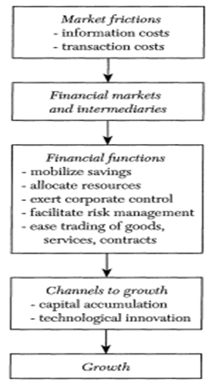
Source: (Levine, 1997, p. 691)

Therefore, it can be said that despite the abundance of research and theories linking financial sector development and economic growth, there is no consensus on the direction of causality. Some researchers argue that financial development causes economic growth, others argue that economic growth causes financial development, and others acknowledge a bidirectional causal relationship between financial development and economic growth.

Results and Discussion:
Research Model:
The research starts from the standard growth accounting framework that divides economic growth into components including production inputs and what is known as Solow residuals, which refer to factors related to technological change and other factors. Based on the proposals by Romer (1990) and Barro (1991), the expanded model of the Cobb-Douglas function, which distinguishes between human capital and physical capital, was adopted. This function can be described as follows:
$$Q=AK^{α} L^{β} H^{γ}$$

Where Q represents total outputs, K represents physical capital, L represents the labor force, H represents human capital, and A represents Solow residuals. The parameters α, β, and γ represent the elasticities of production. The econometric estimation process requires transforming this function into linear form by taking the natural logarithm of both sides, becoming:
$$lnQ=\ln{A+ α}\ln{K+ β\ln{L+γ\ln{H}}}$$

Variables and Data Sources:
This section focuses on understanding the relationship between bank financing and economic growth in Tunisia during the period 1980-2020. The selection of variables was not random but was based on economic theory and previous studies. The variables used in the study can be described as follows:

Dependent Variable:
Real GDP Per Capita in local currency and at 2017 prices as a proxy for Economic Growth. This indicator is one of the most commonly used in empirical studies. The data were obtained from the Groningen Growth and Development Centre for the three countries. This variable is denoted as RGDPPC.

Independent Variables:
Include the following:
  - Physical Capital: Real Gross Fixed Capital Formation as a Percentage of real GDP in local currency and at 2017 prices, as a Proxy for Physical Capital. The data were obtained from the Groningen Growth and Development Centre, and this variable is denoted as GFCF.
  - Labor Force: Average Labour Productivity, calculated by dividing Real GDP in local currency and at 2017 prices by the number of workers, used as a Proxy for the Labour Factor. The data were sourced from the World Bank and the Groningen Growth and Development Centre, and this variable is denoted as ALP.
  - Human Capital: The Human Capital Index is used as a Proxy for Human Capital. The data were obtained from the Groningen Growth and Development Centre, which in turn relied on the Barro-Lee and Cohen-Soto-Leker databases. This variable is denoted as HC.
  - Bank Financing: Domestic credit by banks is used to represent bank financing. The data were sourced from the Arab Monetary Fund database, and this variable is denoted as BC.

Time Series Stability Study:
The step of testing the stability of time series aims to identify the integration order of these series to avoid the possibility of obtaining a spurious regression, in addition to determining the appropriate econometric model for measuring the relationship between study variables, through the following methods:

Time Series Graphs for Study Variables:
From Figure (04-08), which shows the time series for study variables in their logarithmic form, it is clear that all six series contain a general trend. The presence of a general and constant trend in the time series of research variables was verified by conducting regressions for the six variables against the constant and the general trend for each, showing that the constant and the general trend are significant in all six models.

Figure (2): Time Series Graphs.
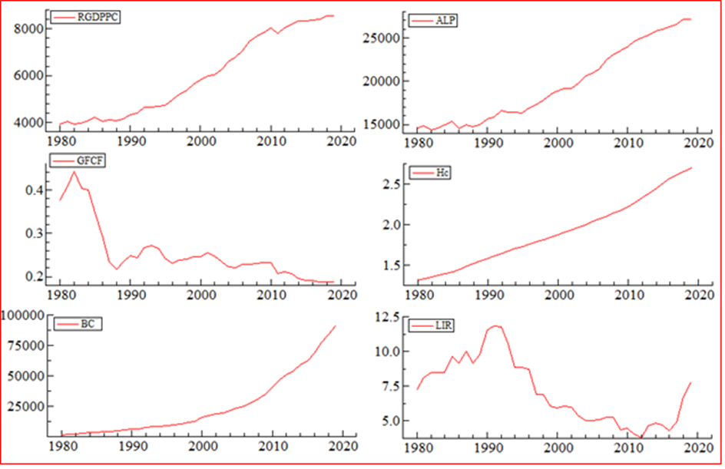
Source: Prepared by the researchers using OxMetrics 7 software.

    - Unit Root Test Results:
The stability of time series is verified by checking for the presence of a unit root. Unit root tests are conducted through three regressions: the first without trend & intercept, the second with intercept only, and the third with trend & intercept. Empirical studies rely on only one of these models, depending on the nature of the series being studied in terms of containing a constant or a general trend. (Lee & Chien, 2008)

According to the equation proposed by William Schwert (1987), the maximum lag periods to overcome the problems faced by unit root tests can be calculated. If this limit is large, it will affect the power of the test, while if it is small, the test will suffer from autocorrelation issues (Arltová & Fedorová, 2016).Given that T = 41 in this study, the maximum lag periods equal:
$$P_{max}= {12\left({41}/{100}\right)}^{1/4} ⇒ P_{Max}≈10$$

The following table shows the results of the ADF and PP unit root tests:
Table (1): Results of Traditional Unit Root Tests (ADF & PP).
Augmented Dickey-Fuller (1979)
Observation | P-value | Critical Value | ADF-stat | Variables
I(1) | 0.0004* | -4.219126 | -5.460054 | RGDP PC
I(1) | 0.0000* | -4.219126 | -6.707039 | ALP
I(1) | 0.0060* | -4.262735 | -4.473723 | GFCF
I(2) | 0.0002* | -4.226815 | -5.726245 | HC
I(1) | 0.0005* | -4.219126 | -5.359439 | BC
I(1) | 0.0029* | -4.219126 | -4.697229 | LIR
Phillips & Perron (1988)
Observation | P-value | Critical Value | PP-stat | Variables
I(1) | 0.0003* | -4.219126 | -5.516100 | RGDP PC
I(1) | 0.0000* | -4.219126 | -6.694044 | ALP
I(1) | 0.0166** | -3.533083 | -4.013945 | GFCF
I(2) | 0.0002* | -4.226815 | -5.726245 | HC
I(0) | 0.0001* | -4.211868 | -6.052115 | BC
I(1) | 0.0029* | -4.219126 | -4.697229 | LIR

*, **, *** significant at 1%, 5%, 10% level of significant respectively.
Model specification: trend and intercept.
Source: Prepared by the researchers using Eviews 12.

From Table (1), there is a discrepancy between the results of the ADF and PP tests for the BC series representing bank financing, where it was stable at the first difference at the 1% significance level in the ADF test, while the same series was stable at level at the 1% significance level in the PP test. The HC series representing human capital was stable at the second difference at the 1% significance level, while the rest of the series were stable at the first difference in both tests at the 1% significance level, except for the GFCF series representing physical capital, which was stable at the 5% significance level in the PP test.

Given Tunisia's economy primarily relies on the marketed services sector and the agriculture and fishing sector, where the marketed services sector contributed 42.2% to the Gross Domestic Product (GDP) in 2019, while the agriculture and fishing sector contributed 10.1% to the GDP in the same year, totaling a contribution of 52.3% to the GDP. Therefore, it's highly probable that their series contain structural changes (shocks), which could result from climatic fluctuations for the agriculture sector, while resulting from economic, security, and even health crises for the marketed services sector.

This makes the known unit root tests unsuitable for determining the stability degree of the series, such as the Augmented Dickey-Fuller (ADF) test (1979), and the Phillips & Perron (PP) test (1988). The presence of even one structural change can bias the test towards

accepting the null hypothesis of a unit root presence despite the validity of the alternative hypothesis suggesting the contrary (Amsler & Lee, 1995). To address this and to reinforce the traditional unit root tests used in this study, the Zivot & Andrews (1992) unit root test, which considers the presence of structural changes, will be used. The following table shows the results of this test:
Observation | Break date | Critical Value | Z&A- stat | K | Variables
I(1) | 2009 | -5.57 | -7.877* | 0 | RGDP PC
I(1) | 2009 | -5.75 | -7.871* | 0 | ALP
I(1) | 1992 | -5.08 | -5.240** | 0 | GFCF
I(1) | 2011 | -5.75 | -7.158* | 0 | HC
I(0) | 2010 | -5.75 | -6.372* | 0 | BC
I(1) | 1993 | -5.75 | -6.194* | 1 | LIR

Table (2): Results of the Zivot & Andrews (1992) unit root test.

*, **, *** significant at 1%, 5%, 10% level of significance, respectively.
K→ Number of lags.
Trend specification: trend and intercept.
Break specification: trend and intercept.
Source: Prepared by the researchers using Stata 17.

The previous table illustrates the unit root test results for the series according to the Zivot & Andrews (1992) unit root test. It was found that only one series among the six time series of the studied variables is stable at level, represented by the BC series indicating bank financing. This is because the test statistic value of Z&A is greater than the critical values at a 1% significance level, thus rejecting the null hypothesis of containing a unit root, and accepting the alternative hypothesis that it is stable at level.

Meanwhile, the other series were not stable at level, hence the first difference was taken, stabilizing all of them. This is because the test statistic value of Z&A is greater than the critical values at one of the statistically accepted significance levels. The RGDP PC series representing economic growth, the ALP series representing labor, and the HC series representing human capital, in addition to the LIR series representing the lending interest rate, all stabilized at a 1% significance level in the first difference.

Moreover, the GFCF series representing physical capital stabilized in the first difference at a 5% significance level. From these results, we conclude that random shocks have a permanent effect on macroeconomic variables. Thus, we have reached what (Perron, 1989) concluded that traditional unit root tests become unsuitable in the presence of structural changes in time series because they are biased towards the possibility of accepting the null hypothesis and rejecting the alternative.

Therefore, only the results of the unit root test that consider structural changes will be adopted, indicating that the time series of the study variables are a mix between those integrated of order zero I(0) and those of first order I(1).

Testing for Long-Run Causality:
To test the causality relationship between the study variables in the long run, the methodology of Toda & Yamamoto (1995) will be used, which is based on the developed Augmented VAR model. The first step is to determine the maximum integration order among the time series, "dmax", which is found to be one, dmax=1.

The second step is to determine the optimal number of lag periods for the study variables based on the Standard VAR model after ensuring the model's econometric robustness and absence of any issues. After estimating the model and conducting validity tests, it was found that the model does not suffer from any econometric problems. On this basis, the optimal number of lag periods can be determined as shown in the following table:

Table (3): VAR Lag Order Selection Criteria for Study Variables.
HQ | SC | AIC | FPE | LR | LogL | Lag
-13.9603 | -13.7937 | -14.0523 | 3.2e – 14 |  | 272.994 | 0
-28.2665 | -27.1005* | -28.9104 | 1.1e -20 | 636.61 | 591.298 | 1
-29.16* | -26.9946 | -30.356* | 3.1e – 21* | 126.93* | 654.763 | 2

*Optimal lag
Source: Prepared by the researchers using Stata 17.

From the results of the table, it is clear that most criteria agreed that the optimal number of lags for the study variables is two, P=2. Therefore, after determining the highest integration order and the optimal lag degree, the developed Augmented VAR model will be estimated, in other words, estimating the (P+dmax)th order VAR model.

Model Validity Tests:
After the statistical processing of the model, and before its adoption and interpretation of its results, it must undergo a series of tests to determine its robustness. These tests are divided into two types:
    - Residuals Diagnostics Tests:
Below are the results of the tests related to the series of residuals, including the Serial Correlation LM test, Normality test, and Heteroskedasticity test.
- Autocorrelation LM Test:

To verify that the model does not suffer from autocorrelation, the VAR Residual Serial Correlation LM Test was used. The results summarized in Table (04-25) indicate that this model does not suffer from autocorrelation at the lag periods automatically selected by the software. This is because the P-value is statistically insignificant at all levels of significance, leading us to accept the null hypothesis that the residuals series of the study model does not suffer from autocorrelation and to reject the alternative hypothesis.

Table (4): VAR Residual Serial Correlation LM Tests.
Var residual Serial Correlation LM Tests
Sample: 1980-2020
Included observations: 38
Null hypothesis: no autocorrelation at lag order
Prob > Chi2 | Df | Chi2 | Lag
0.48818 | 36 | 35.5850 | 1
0.50517 | 36 | 35.2270 | 2

Source: Prepared by the researchers using Stata 17.
  - Normality Test:

To ensure that the residuals series of the model follows a normal distribution, the Jarque-Bera test was used. The results show that the probability value of the Jarque-Bera statistic for all model equations was statistically insignificant at all levels of significance, leading directly to accepting the null hypothesis that the residuals series follows a normal distribution.

Table (5): Jarque-Bera Normality Test.
Prob | df | Jarque-Bera | Equation
0.80969 | 2 | 0.422 | RGDPPC
0.27854 | 2 | 2.556 | ALP
0.37137 | 2 | 1.981 | GFCF
0.97122 | 2 | 0.058 | HC
0.27472 | 2 | 2.584 | BC
0.87596 | 2 | 0.265 | LIR
0.79544 | 12 | 7.867 | Joint

Source: Prepared by the researchers using Stata 17.

  - Heteroskedasticity Test:
To ascertain the model does not suffer from heteroskedasticity, the VAR Residual Heteroskedasticity Test was used. The results summarized in Table (6), show that the probability values of the Arch statistic were all statistically insignificant at all levels of significance, leading directly to accepting the null hypothesis of homoscedasticity of the residuals series.
Table (6): VAR Residual Heteroskedasticity Test.
Prob | ARCH | Equation
0,107001 | 4,46984 | RGDPPC
0,105274 | 4,50237 | ALP
0,627817 | 0,931014 | GFCF
0,197604 | 3,24298 | HC
0,873221 | 0,271134 | BC
0,545112 | 1,21353 | LIR

Null hypothesis: no ARCH effect present
Source: Prepared by the researchers using Gretl 2022a.

- Model Structure Stability Test:
To ensure the model's structural stability and robustness, the model will be subjected to the Inverse Roots of AR Characteristic Polynomial test. The results, shown in Figure (3), indicate that the model's roots fall within the critical boundaries, i.e., inside the unit circle, meaning the model's structure is stable.
Figure (3): Results of the Inverse Roots of AR Characteristic Polynomial Test.
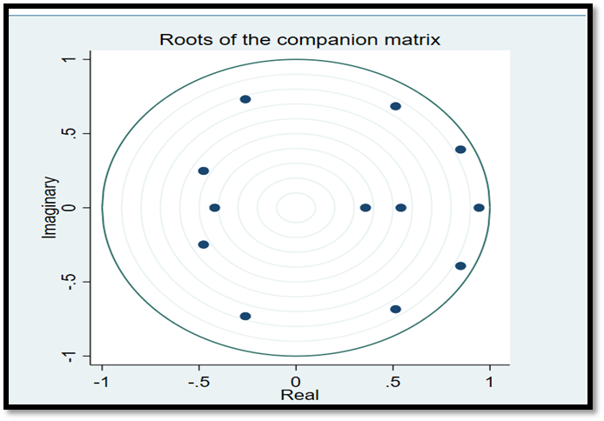
Source: Prepared by the researchers using Stata 17.
After successfully passing all validity tests, it can be stated that the model exhibits econometric robustness and can be relied upon to measure the long-term causal relationship according to the Toda & Yamamoto (1995) methodology.

2.5 Testing Long-Term Causality:
After verifying the econometric robustness and validity of the model, the causality relationship between the model's variables in the long term, according to the Toda & Yamamoto (1995) methodology or the Test of non-Granger causality will be tested. The following table shows the results of this test:
Table (7): Results of Long-Term Causality Test According to Toda & Yamamoto (1995) Methodology.
Independent variable |  |  |  |  |  | Dépendent variable
LIR | BCPS | HC | GFCF | ALP | RGDPPC
[15.227] (0.002) | [15.473] (0.001) | [3.974] (0.264) | [6.7582] (0.080) | [7.3039] (0.063) | - | RGDPPC
[10.102] (0.018) | [20.677] (0.000) | [2.9238] (0.404) | [10.843] (0.013) | - | [9.4368] (0.024) | ALP
[21.583] (0.000) | [14.943] (0.002) | [17.817] (0.000) | - | [6.7268] (0.081) | [12.321] (0.006) | GFCF
[12.057] (0.007) | [27.207] (0.000) | - | [20.35] (0.000) | [3.9089] (0.271) | [10.413] (0.015) | HC
[34.043] (0.000) | - | [19.269] (0.000) | [24.505] (0.000) | [18.628] (0.000) | [13.209] (0.004) | BCPS
- | [16.065] (0.001) | [34.195] (0.000) | [40.337] (0.000) | [83.707] (0.000) | [124.69] (0.000) | LIR

[ ]: Chi-square of Modified Wald test.
( ): P-value of Modified Wald test.
Source: Prepared by the researchers using Stata 17.

The results of the long-term causality test according to the Toda & Yamamoto (1995) methodology indicate that the main variable BC representing bank financing is causally related in a bidirectional manner in the long run with the variable RGDP PC representing economic growth, at a significance level of 1%. This is evident from the accompanying P-Value of the chi-square statistic for the Modified Wald test, which was "0.001" for the relationship between BC and RGDP PC. Therefore, we reject the null hypothesis that BC does not cause RGDP PC and accept the alternative hypothesis that BC causes RGDP PC. Similarly, the P-Value for the relationship between RGDP PC and BC was "0.004," also significant. Hence, we reject the null hypothesis that RGDP PC does not cause BC and accept the alternative hypothesis that RGDP PC causes BC.

Likewise, the variable LIR representing the lending interest rate is causally related in a bidirectional manner in the long run with the variable RGDP PC representing economic growth, at a significance level of 1%. This is evident from the P-Value of "0.002" for the relationship between LIR and RGDP PC, rejecting the null hypothesis that LIR does not cause RGDP PC and accepting the alternative hypothesis. The P-Value for the relationship between RGDP PC and LIR was "0.000," also significant. Therefore, we accept the alternative hypothesis that RGDP PC causes LIR and reject the null hypothesis.
The same applies to the variable ALP representing labor, which is causally related in a bidirectional manner in the long run with the variable RGDP PC representing economic growth, at a significance level of 10%. The P-Value for the relationship between ALP and RGDP PC was "0.063," rejecting the null hypothesis that ALP does not cause RGDP PC and accepting the alternative hypothesis. The P-Value for the relationship between RGDP PC and ALP was "0.024," also significant. Therefore, we reject the null hypothesis that RGDP PC does not cause ALP and accept the alternative hypothesis.

Regarding the variable GFCF representing physical capital, it is causally related in a unidirectional manner in the long run with the variable RGDP PC representing economic growth, with a P-Value of "0.080" at a significance level of 10%. Thus, we reject the null hypothesis that GFCF does not cause RGDP PC and accept the alternative hypothesis. The P-Value for the relationship between RGDP PC and GFCF was "0.006," also significant. Therefore, we reject the null hypothesis that RGDP PC does not cause GFCF and accept the alternative hypothesis.

However, the variable HC representing human capital is causally related in a unidirectional manner with the variable RGDP PC representing economic growth. The P-Value for the relationship between HC and RGDP PC was "0.264," non-significant at all levels of significance. Therefore, we accept the null hypothesis that HC does not cause RGDP PC and reject the alternative hypothesis. However, the relationship from RGDP PC to HC had a P-Value of "0.015," significant at a 5% level, leading us to reject the null hypothesis of no causality and accept the alternative hypothesis of causality from RGDP PC to HC.

CONCLUSION:
This study aimed to test the long-term causality relationship between bank financing and economic growth in Tunisia during the period from 1980 to 2020. It employed the Toda & Yamamoto (1995) methodology, which is based on the developed Augmented VAR model, estimating it based on the results of the time series stability test and the optimal lag degree. After conducting all model validity tests and confirming its econometric robustness, the causality test according to the Toda & Yamamoto (1995) methodology was carried out.

The study concluded that there is a bidirectional causal relationship between bank financing and economic growth. Therefore, bank financing is one of the causes leading to economic growth in Tunisia, aligning with most economic theories like those of Schumpeter (1911), Hicks (1969), Goldsmith (1969), McKinnon (1973), Shaw (1973), Fry (1988), Levine & King (1993), and Levine (1997). According to Patrick (1966), Tunisia is considered to be in the advanced stages of development because financial development follows economic growth and not vice versa (the demand-following phenomenon).

RECOMMENDATIONS:
Based on the findings of this study, several recommendations that could give the banking sector in Tunisia an important and effective role in achieving economic prosperity are presented:
- Given that bank financing leads to economic growth, Tunisian authorities should support and develop the banking sector, encourage commercial banks to adopt the principle of universal banking, and increase credit facilities offered to various sectors.
- Since the lending interest rate causes economic growth, mirroring the significant economic role central banks play in developed countries, the Tunisian Central Bank should play a similar role by targeting vital economic sectors with high contributions to GDP with preferential interest rates. This would encourage investors to seek financing and invest in these sectors, thereby stimulating economic growth.
- Tunisian authorities should enact laws to help commercial banks integrate into the economic reality and enhance their role in economic growth, not limiting their role to financial intermediation only but expanding it through active participation in investment activities. This involves owning companies and investment projects, creating a competitive investment climate.

BIBLIOGRAPHY

- Amaira, B. (1993). FINANCE AND GROWTH: SCHUMPETER MIGHT BE RIGHT. The Quarterly Journal of Economics, 108(3).
- Amaira, B. (2017). Reforms and performances of the Tunisian financial system. Tunisian Institute of Competitiveness and Quantitative Studies(46), p. 06.
- Amsler, C., & Lee, J. (1995). An LM Test for a Unit Root in the Presence of a Structural Change. Econometric Theory, 11(2), 359-360.
- Arltová, M., & Fedorová, D. (2016). Selection of Unit Root Test on the Basis of Length of the Time Series and Value of AR(1) Parameter. Statistika: Statistics and Economy Journal, 96(3).
- Brou, E. A. (2005). THE ROLE OF CAPITAL MARKETS IN ECONOMIC GROWTH AND DEVELOPMENT. doctoral thesis. Faculty of Economic Sciences and Management, Clermont-Ferrand: University of Auvergne.
- King, R., & Levine, R. (1993). FINANCE AND GROWTH: SCHUMPETER MIGHT BE RIGHT. The Quarterly Journal of Economics, 108(3).
- Lee, C., & Chien, M. (2008). Structural breaks, tourism development, and economic growth: Evidence from Taiwan. Mathematics and Computers in Simulation,, 77(4), 362-363.
- Levine, R. (1997). Financial Development and Economic Growth: Views and Agenda. Journal of Economic Literature, 35(2).
- Patrick, H. T. (1966). Financial Development and Economic Growth in Underdeveloped Countries. Economic Development and Cultural Change,, 14(2).
- Perron, P. (1989). The Great Crash, the Oil Price Shock, and the Unit Root Hypothesis. Econometrica, 57(6), 1361-1401.
- Sahrawi, D. (2017). An Econometric Study of the Impact of Financial Liberalization Policy on Economic Growth: Case Study of Algeria during the Period 1990-2014. Doctoral dissertation. Faculty of Economic Sciences, Commercial Sciences and Management Sciences, Médéa: Yahia Fares University.
- Stemmer, M. A. (2016). Essays on Growth, Unemployment and Financial Development . PhD thesis. Paris, Maison des Sciences Économiques, France: University of Paris 1 Panthéon-Sorbonne.
- Thao, N. T. (2005). THE RELATIONSHIP BETWEEN DEVELOPMENT AND ECONOMIC GROWTH: CASE OF VIETNAM. Master's thesis. School of Management Sciences, Montreal: UNIVERSITY OF QUEBEC AT MONTREAL.

